2023-2026
Pastor Tim Lichtley
Brownstown Church of the Nazarene

Action Plan
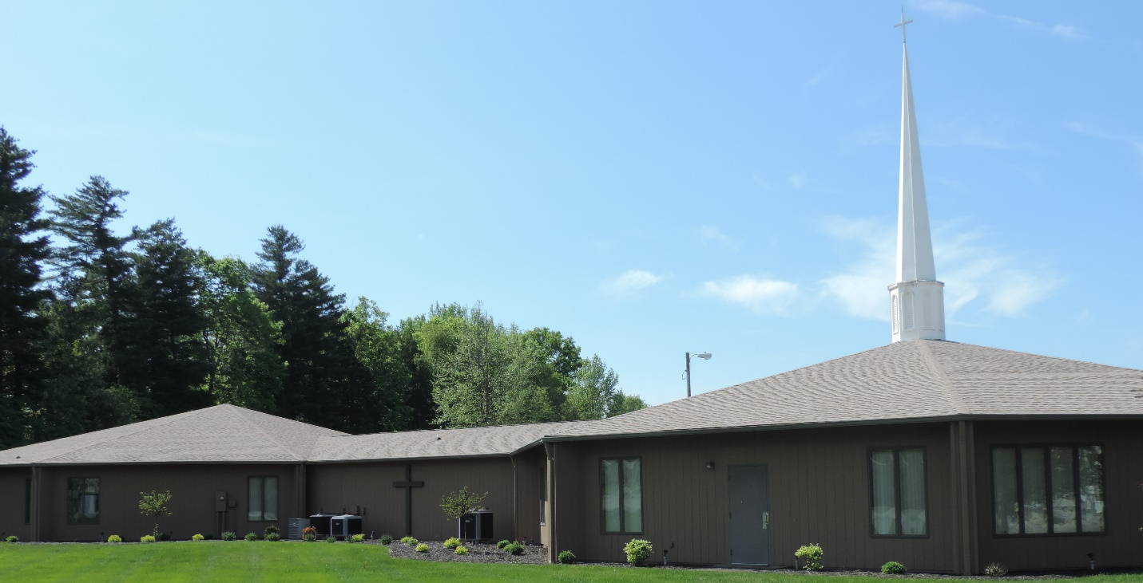
I desire to place before you my hopes, dreams, and intention for the years 2023-2026. The following goals are the product of many planning sessions with congregation members, church board members, and general conversations held with church members. Additionally, these goals formed out of many hours of prayer and divine guidance. The following pages are not a comprehensive list of all we aspire to do in the coming years, but they do lay the foundation for what is to come.

I aspire to make these goals a reality with the help of God, the church, and the power of the Holy Spirit. I commit myself to this plan and being open to God's direction in our endeavors. I furthermore devote myself to serving you well through sound Biblical preaching, Godly leadership, pastoral care, and investments in your spiritual growth.

Many months ago, the church board adopted the following statement as our mission/purpose statement for the coming years.

To know, love, serve, and share Christ, discipling others.

As you can see, there are five key areas we are committed to becoming. We seek to know God, love others, serve our community, share Christ, and invest in the spiritual development of people. While the COVID years have slowed our progress slightly, God is again renewing our desire to fulfill our mission in these areas. The goals and action steps set before you will help us better achieve our mission and keep us moving forward.

One of a leader's greatest tasks is to define reality. Only after our reality is defined can we begin to face the problems before us and resolve to correct these problems. Over the last five years, we have seen decreases in our overall membership, worship attendance, and Sunday School attendance. There are many contributing factors to this, including an aging congregation and two years of dealing with COVID. Additionally, overall giving has decreased, participation in ministry is down, and we are failing to reach new people, especially those in the younger category.

Over the last year, we have begun to take small steps to help in these areas, including introducing online giving, creating a college and career Sunday School class, men's and woman's ministries, and emphasizing outreach events. We are seeing a slight uptick in our attendance since returning from COVID, averaging 98 since September 2022. We have had six Sundays with over 100 in attendance, with 136 being our highest. There is a renewed sense of God's presence in our worship services, including an incredible Weekend of Renewal in September which saw the altars full on two occasions.

A new day is now before us, and with it, new opportunities and vision. Our vision is to become a multigenerational church dedicated to transforming lives and fostering spiritual growth in the individual. We must continue to adapt, change, and be open to new ideas for ministry as we seek to be a bridge to our community in this changing world. The road ahead will require hard work, sacrifice, determination, and willingness to trust God. I am asking you to join me in praying for God to grow our church through conversions, spiritual transformations, increased attendance, and a renewed passion for the lost souls of Jackson County.

I believe that over the next three years, as we achieve our goals, we as a church can:

- Average over 150 in morning worship attendance
- Receive 25 new Nazarenes into membership
- Obtain 80% participation in ministry among our congregation
- 90% of our people connected to a Sunday School Class or small group
- Begin at least one new ministry in a different town
- Increase overall giving to $300,000
- Increase our youth ministry participation to 30
- Increase children's participation to 30
- Every Sunday school class and small groups participating in regular times of fellowship
- Actively serving our community through monthly service projects

To clarify our goals, we have broken our goals into six primary areas: Worship, ministry, discipleship, evangelism, fellowship, and facilities. Each area includes goals and dreams we strive to achieve over the next one to three years. As mentioned above, these goals are just the beginning, and we will introduce other goals as we progress on our initial goal list.

I believe that today, these goals will become a reality, and as they do, our church will grow, and we will discover the goodness of God in more significant measure.

Worship Goals
- We will get more people involved in our worship experience by utilizing the praise team, musicians, special music, prayer, ushers, communion servers, and greeters.
- Continually emphasize prayer through creating prayer groups, Sunday morning prayer times, prayer conferences, teaching on prayer, and individuals praying during services.
- Strive for Spirit-led and inspired worship by creating an atmosphere where people are free to worship as the Lord leads and by limiting things that hinder the flow of the worship service.

Ministry Goals
- Improve our children's ministry by updating the children's ministry room with new carpet and paint, creating a worship area and an activity and learning area. Provide catechism and discipleship training for children. Train children's ministry volunteers, supply an exciting Biblical-based curriculum, create an after-school program, and create the best children's ministry in Brownstown.
- Create and assign visitation Teams to visit shut-ins, the sick, and our church family and to connect with new attendees.
- Greater Emphasis on Ministry to our community by creating ministry teams that will go into the community to do service projects, assist those in need, and partner with community officials as needed
- Additionally, we will strive to make our church a community center by hosting events that provide services to our community, such as Life-Line Screenings, Blood Drives, and informational seminars.

Discipleship Goals
- We will develop a School of theological learning to assist people in going deeper into the faith by studying topics of theology, the church, and the Christian life.
- Renew our emphasis on Sunday School and Small groups. We will strive to connect every church member to a Sunday school class or small group by starting new courses, targeting specific age groups, and offering classes to meet specific needs.
- We will implement a Systematic Discipleship Process to help move people along in their spiritual journey. We seek to provide tangible ways to measure growth and progress in our attempts at discipleship. We will create a discipleship map and learning system to provide resources to assist spiritual growth.

Evangelism Goals
- As a church, we will continue our emphasis on special events. We will provide events and opportunities designed to introduce the unsaved to our church in a relaxed, less threatening atmosphere. By providing seasonal events, fifth Sunday night activities, and special services, we can invite people to church and develop deeper relationships with our community.
- We will expand our digital footprint by utilizing social media to promote church functions, share worship services, and connect with people through blogs, podcasts, vlogs, and other social media posts.
- With God's help, we will start a work/ministry in Medora Area. Following the lead and challenge set forth by our District Superintendent to begin new churches in areas void of Nazarene influence, we seek to start a new ministry in Medora.

Fellowship Goals
- Our goal moving forward is to utilize our church grounds more efficiently. We will plan outdoor events to create community and connect us with the unchurched. We seek to use our grounds for outdoor concerts, movie nights, picnics, bonfires, campouts, and other activities that create an atmosphere for getting to know one another.
- We challenge every Sunday School class and small group to schedule regular gathering times for fellowship and community-building.
- In addition to class gatherings and outdoor activities, we seek to build into our church calendar outings that will foster community. We will offer events such as a night at the ballpark, day trips, overnight tours, concert excursions, and other events of interest.

Facility Goals
- We understand that parts of our facility are now thirty years old. For this reason, we need many updates and improvements. We seek to update our sanctuary by replacing our current projectors, adding new screens, replacing the existing carpet, exploring lighting options, and repainting the walls.
- Additionally, our restrooms also need a makeover. The tile in all the restrooms needs replaced, stalls need updated to something more modern, fresh paint is required, and vanities added to the lady's restrooms.
- We desire to develop our property by building a picnic shelter, sand volleyball pit, outdoor basketball court, prayer garden, and walking trail.
- Other needed improvements include paving the parking lot, fixing light fixtures throughout the building by converting them to LED, replacing air conditioners as needed, and replacing the carpet in other parts of the building.

The road ahead is not an easy one, but the future of our church depends on our ability to achieve these goals. We must serve the lost and commit to transforming lives with the Gospel. Our church has a rich history of men and women who faithfully prayed for a church dedicated to the message of holiness in Brownstown. Through the years, the members of this church dared to dream. These faithful people bought buses, developed new property and facilities, and reached the community with the message of holiness. As we look to the future, it is our turn to carry on the rich tradition of those who came before us. May we dream big and faithfully serve, and our preferences and traditions never trump what God is trying to do.

The future is bright, and the possibilities are endless for a church devoted to God and his plan. May we be those people, and may these goals, with God's help, become a reality.

